Friday 20th May 2022

Geography Revision – Physical Geography

Distribution of Earthquakes and Volcanoes

* Surrounding plate boundaries
* Hotspots that occur in the centre of plates
* Mountainous regions where landforms that have been formed by volcanoes and earthquakes.

Constructive (for example Iceland):

* Formed by two plates moving away from each other.
* Earthquakes.
* Shield Volcanoes (caused by fast-moving magma).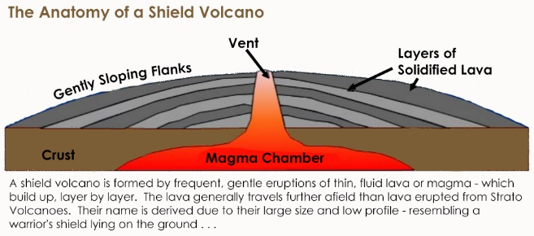

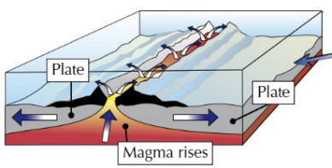

Destructive (for example Chile):

* Formed by two plates moving towards each other, the denser oceanic plate subducts (moves below) the other plate.
* Earthquakes
* Mountain Ranges
* Composite Volcanoes

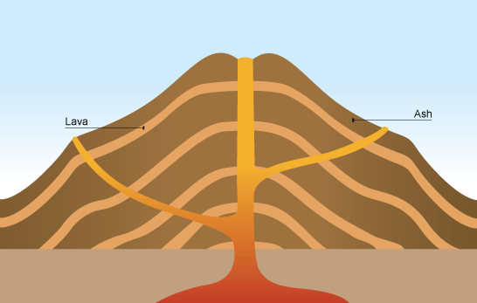

Conservative (for example California/San Andreas Fault):

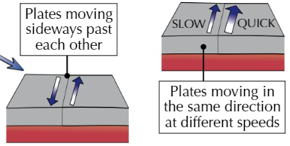

* Formed by two plates moving against each other or moving the same direction.
* Earthquakes

Hotspots:

* Hot areas in the centre of plates.
* Whilst not technically plate margins, volcanoes can still form here.

Prediction of Volcanoes

Seismograms – Measure vibrations in the Earth’s crust and measures the magnitude of earthquakes.

Tiltmeters – Detects change in angle of terrain which is caused by shifting magma below the surface.

Satellite Imagery – Satellites can be used to detect tiny movements over a large area.

Time-Lapse Cameras – Allow geologists to make observations from a safe distance.

Richter Scale

* Measures the magnitude of a tremor using a seismograph.
* Logarithmic scale – 5 is 10x more powerful than 6 (x10 increase moving up the scale)